Activity 5: Paleolimnological reconstruction of the Pasvik River environment based on diatom analyses

Trilateral cooperation on Environmental Challenges in the Joint Border Area

Dmitrii Denisov
Institute of North Industrial Ecology Problems, Kola Science Center, RAS

This publication has been produced with the assistance of the European Union, but the contents of this publication can in no way be taken to reflect the views of the European Union.

Introduction

Comprehensive environmental monitoring of the Pasvik River catchment area largely depends on the results of studies of long-term changes under the influence of both industrial activities and natural changes of the environment and climate. Based on all these data, one shall be able to determine more accurately the fields of monitoring, understand the current processes, and identify the roles of and relations between the natural and industrial factors.
It would be impossible to identify the reasons for various current changes in the river-and-lake system of Pasvik and the factors responsible for its development without the knowledge about the history of ecosystems development, as well as the range of natural fluctuation of biological parameters without considering the industrial factor. The information about specific features of the environment in the past allows reliable estimation of the background values, as well as identification of the roles of climate change in the ecosystems transformations, which is especially important in the analysis of industrial factors’ contribution to the transformation of biological resources in northern regions. In this context, it is small lakes of glacial origin in the river’s catchment area that are the most suitable objects for obtaining paleo-ecological information for reconstruction of the historical dynamics of the environment and climate.

Materials and methods

Three lakes were selected for the study of diatom complexes of bottom sediments – one lake in the territory of each country (Finland, Norway, and Russia) (Fig. 1). The selected water bodies are characterized by small depths, sufficient for formation of uninterrupted layers sequence of bottom sediments; besides, these lakes were investigated in the course of earlier international monitoring programs, which allows using the previously obtained data for historical reconstructions.
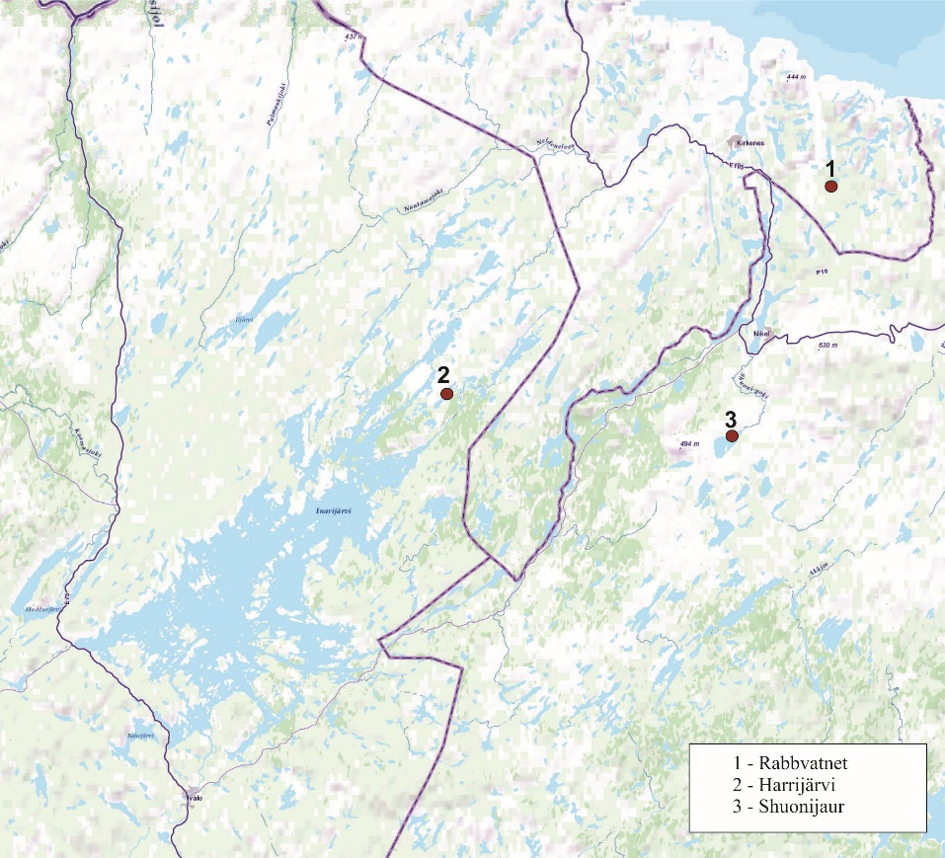
Figc.1. Map-scheme of the sediment cores sampling stations (River Pasvik watershed)

Sampling was performed with gravity type open samplers in the area of maximum depth in each water body (accumulation zone). Diatom analysis of bottom sediments was carried out according to the standard generally accepted method (Diatom analysis, 1949; Davydova, 1985; Denisov et al., 2006; Denisov at al., 2007; Kashulin et al., 2008). The columns were divided into 1 cm layers (for Lake Rabbvatnet the upper part of the column was divided into layers 0.5 cm) that served as the material for all types of analysis (see the section on sediments and sedimentation rates). Calculations of sedimentation rates for each of the water bodies based on ²¹⁰Pb and ¹³⁷Cs allowed identifying the age of the bottom sediments layers.
All diatoms’ valves discovered in the samples were identified as possible to intraspecific taxonomic categories according to the guidebook (Krammer, Lange-Bertalot, 1988-2003). Calculation and taxonomic identification of diatoms was performed on optical microscope “Motic BA 300” with х400-1,000 magnification, with the use of immersion lens. Immersion oil “Cargille” Type B (nD= 1.5150 ± 0.0002) was used.
Further analysis included investigation of taxonomic structure of diatom complexes, dynamics of relative abundance (%) of the predominant species, and estimation of the total amount of valves in the sediment. Species diversity was estimated according to Shannon-Weaver index (H’ bit/ex.). The total amount of valves was identified for each investigated layer in the bottom sediments (mln.ex. /g).
Tolerance analysis was made for the discovered taxa in relation to pH, and integral pH value was calculated for each sediments layer according to the authors’ method (Moiseenko, Razumovsky, 2009) using the equation:

$$\text{pH}\text{=}\frac{\sum{\text{ph}\text{i}\text{k}}}{\sum{\text{k}}}$$

where ph_{i} is the individual value or each taxon-indicator; k is the abundance indicator expressed in points or abundance numbers. In this study, the abundance number of each taxon-indicator was used as k.
Thus, the following were identified: neutrofilic – with development optimum at pH 7.0, indifferent – capable to develop in a relatively wide range of pH, alkalifilic – preferring pH> 7.0, alkalibiont – pH 7.6 and above, acidofilic – pH< 7.0, and acidobiont – developing at relatively low pH 6.4 and below.
Ecological groups of diatoms and their ratio in each sediment layer were analyzed for reconstruction of conditions in each water body:
- according to their habitat – plankton, benthic and plankto-benthic forms;
- according to their reaction to water salinity: halophob, indifferent, oligohalob, halofilic, mesohalob;
- according to bio-geographical association: cosmopolitan, arctic-alpine, boreal, holarctic.
For each layer, saprobity index S was calculated as an indicator of presence of biogenic nutrients in the environment, and also as an indirect indicator of the lakes’ trophic status (Sladecek, 1967; Barinova et al., 2006). Data of ecology of specific algae taxa, individual saprobity indicators, and reaction to pH from the updated database on algae ecology (Barinova et al., 1996, 2006) were used in the analysis.

Results and discussion
Shuonijaur Lake. Diatom complexes in the top layer of sediments were analyzed (interval 0.5-1cm) as the ones reflecting the present-day status of the lake ecosystem, as well as the bottom part of the column (13-14cm) formed ca. 200 years ago, before the intensive industrial transformations.
The typical representatives in the diatom complexes were, as follows: Aulacoseira alpigena (Grun.) Kramm.; Aulacoseira distans (Ehrb.) Simons. Cyclotella schumannii (Grun.) Håk., C.rossii Håk.; Tabellaria flocculosa (Roth) Kütz. Thus, the plankton representatives typical of water bodies in North Europe were the massive ones. The same diatoms were found in the present-day plankton of the lake.
In the lower part of the column the similar aggregate of massive species are complemented by Cyclotella michiganiana Skvortzov 1937; C. bodanica var. lemanica (O. Müll. ex Schröter) Bachm. and Pseudostaurosira brevistriata (Grun.) D.M. Williams & Round. The presence of the latter is a sign of more favorable trophic conditions for algae development.
Obviously, no radical changes have taken place in the lake over this period. A certain increase of diatoms’ total abundance was observed, along with a decrease of taxonomic diversity in the modern sediments as compared to the older sediments. The modern conditions are also characterized by lower values of pH and saprobity index S (fig. 2). Based on this, one cannot speak of acidification because the pH is around neutral values with a slight shift towards alkaline. The decrease of saprobity index is a consequence of a certain shift of the lake’s trophic status towards oligotrophy. Thus, presently, typical subarctic conditions are currently preserved in the lake, similar to those that existed 200 years ago.

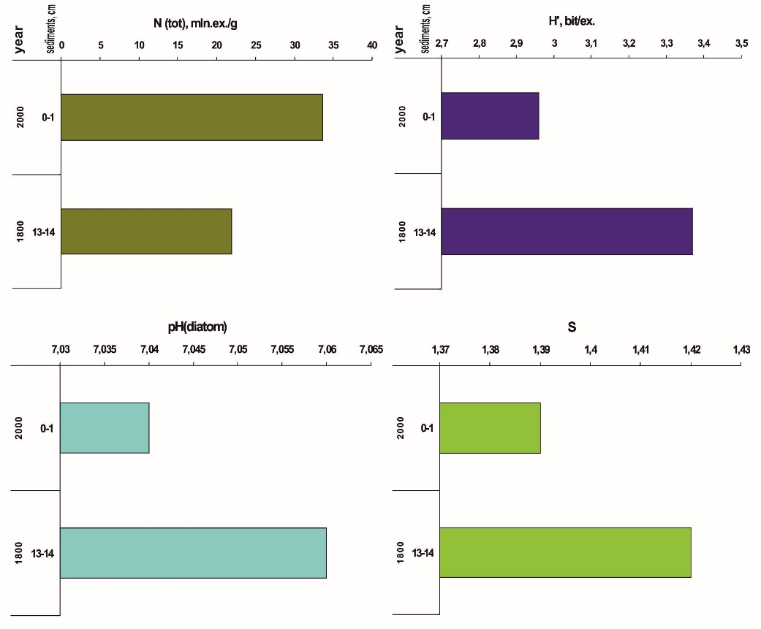
Fig.2. Diatom complexes of the Shuonijaur Lake: total abundance (N(tot), mln.ex./g); specific variety (H’, bit/ex.); diatom-infer reconstructed pH (pH(diatom)); saprobe index (S).

Absence of significant changes of ecological conditions in Shuonijaur Lake is confirmed by the dynamics of diatom groups in relation to the environment factors (fig.3). The reaction of diatoms to pH has not virtually changed, except for some decrease of the alkalifilic portion. Salinity also remained at the same level: the halophobs and oligohalob-indifferent predominate which is typical of low-mineralized waters. The water level and water content has not changed significantly in the lake: the portion of plankton forms remained at the same level. Decrease of the amount of plankton-benthic diatoms along with increase of benthic diatoms may be a sign of changes in the shoreline, type of bottom and substrate, which supports the development of richer benthic communities. The modern data also confirms this – diatom periphyton densely covers the littoral rocks as well as rocky areas of the bottom down to 2.5-3 meters deep.
The ratio between the bio-geographic groups of diatoms has not changed virtually over the latest 200 years. The increase of the portions of boreal (from 23% to 29%) and halo-arctic (from 4% to 11%) species may be regarded as an indirect indicator of a certain climate change towards warming (fig. 3, d); at the same time, the portion of arctic-alpine species remains the same.

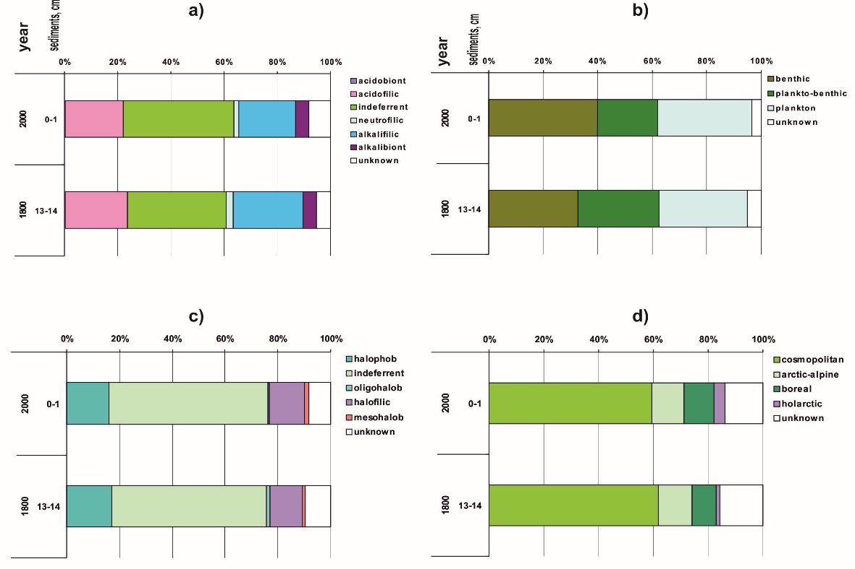
Fig.3. Ecological characteristics of the diatom complexes in the ShuonijaurLake: a) –pH-tolerance groups; b) – habitat groups; c) – salinity groups; d) – biogeographic groups.

Thus, the ecological conditions in Shuonijarvi Lake over the latest 200 years have not virtually changed; for the whole period under study the water body has been consistent with subarctic lakes type, with low salinity and oligotrophic trophic status. Arctic-alpine forms are found in the diatom complexes of both aged (200 year-old) and modern bottom sediments. The quantitative prevailing of the benthic forms over planktons is an evidence of numerous shallow-water areas suitable for development of diatom benthos and periphyton, and also illustrates high transparency of the water for the whole duration of the period under study. The increase of the total abundance of diatoms in the modern sediments as compared to the aged sediments along with the decrease of the species diversity, as well as increase of the portion of boreal and haloarctic forms may have resulted from climate changes toward warming.
Harrijarvi Lake. Diatom complexes in the top layer of sediments (interval 0-1 cm) were analyzed – reflecting the current status of the lake’s ecosystem, as well as in different parts of the column (intervals 5-6, 11-12, 15-16, 18-19 and 29-30 cm) formed in different historical stages of the lake’s development. Totally, the age of sediments investigated amounted to 240 years.
The typical representatives in the diatom complexes were: Brachysira brebissonii Ross; B.vitrea (Grun.) Rossin Hartley; Frustulia saxonica Rabenh.; Cyclotella comensis Grunowinvan Heurck 1882. In the older layers the diatom complexes also included Cyclotella kuetzingiana Thwaites and Aulacoseira alpigena (Grun.) Kramm. Thus, the benthic representatives typical of North European water bodies with pH< 7.0. were massive. Brachysira brebissonii, B. vitrea, and Frustulia saxonica are massive in the modern periphyton of the lake. No dramatic differences were found in the species composition for the period under study.
The dynamics of the total abundance of diatoms (N) is characterized by gradual increase beginning from the lower intervals of the sediments and reaches the maximal values in the sediment layer 15-16 cm which is 130 years old. Later, between the XIX and XX centuries dramatic drop of N had place and lasted until 1950’s, and, after that the total abundance of diatoms has been growing until today (fig.4).

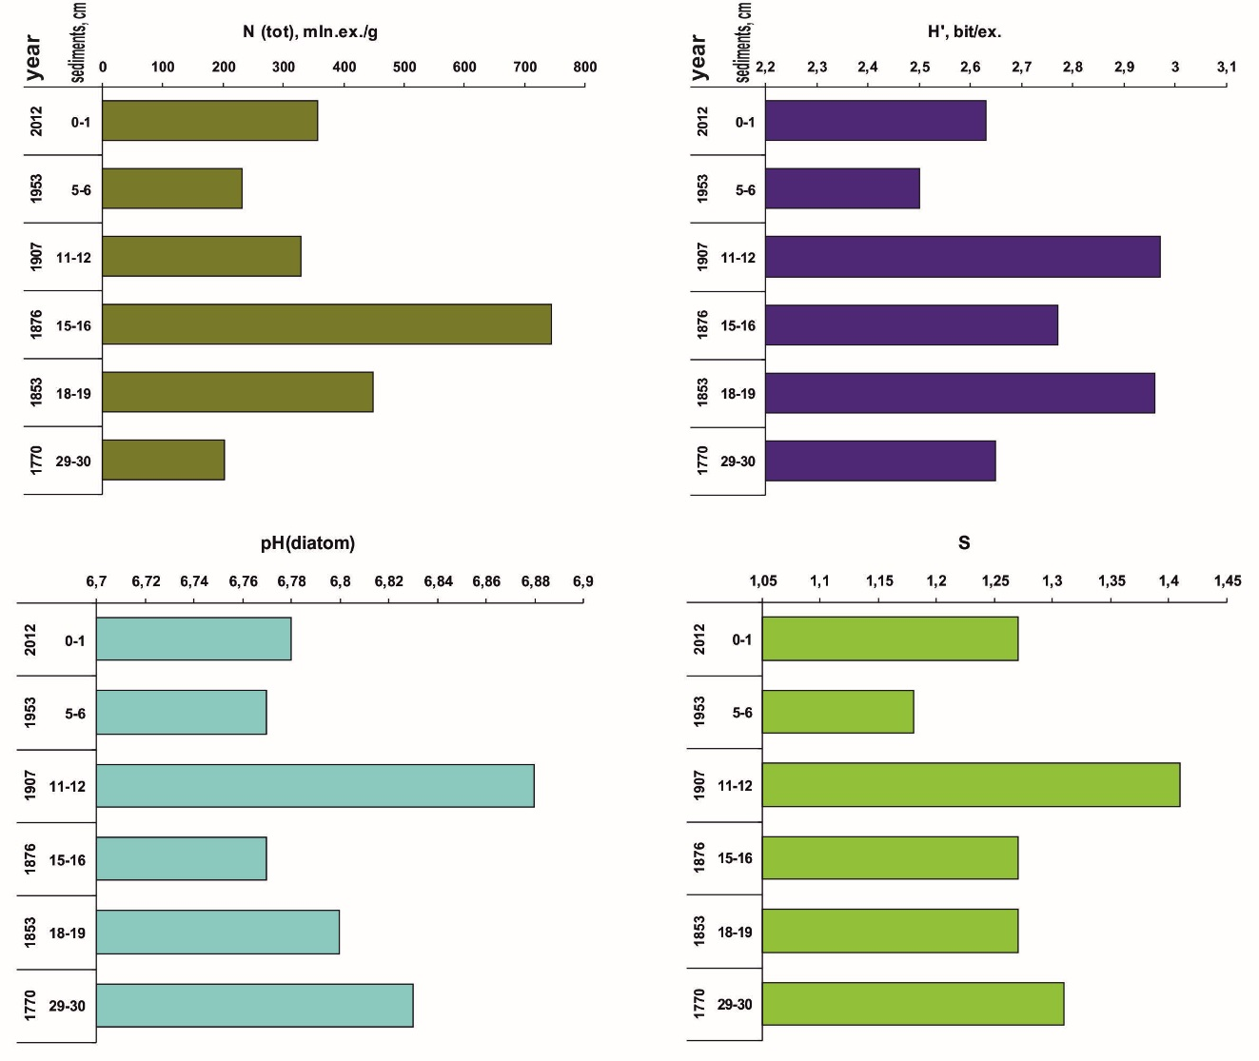
Fig.4. Diatom complexes of the Harrijarvi Lake: total abundance (N(tot), mln.ex./g); specific variety (H’, bit/ex.); diatom-infer reconstructed pH (pH(diatom)); saprobe index (S).

The maximal values of diatoms’ abundance had place at the end of the XIX century – in that period the benthic species preferring pH<7.0 – Frustulia saxonica and Brachysira brebissonii – were especially abundant in the lake, as well as planktons Cyclotella comensis, Aulacoseira alpigena; plankton-benthic – C. kuetzingiana. This is likely to be linked with pH decrease resultant from hydrologic-and-hydrochemical water catchment processes causing water acidification with humic acids coming from the soils and swamp waters. It is possible that in the same period could develop bryophytes that Frustulia saxonica and Brachysira brebissonii using as substrate.
Growth of the relative abundance of diatoms in the bottom sediments at the turn of the XX century was also determined in other lakes, for example, in Saanajärvi Lake (Korhola et al., 2002). Change of climatic conditions during transition from Little Ice Age to warming early in the XX century could also be the reason for growth of general abundance of diatoms. Warming has also led to some increase of water volume in the lake, which is confirmed by the reduction of the portion of benthic diatoms, and also it led to growth of pH. The maximum saprobity index (1.41) is the evidence of temperature rise in this period for the studied column.
Later, from the beginning and until the middle of the XX century the general abundance of diatoms reduced against the background of the reduction of species diversity and pH (Fig.4). Probably, these changes were primarily determined by transformation of hydrochemical conditions as a result of aerotechnogenic pollution with the emissions from the Pechenganikel integrated plant. Deposition of acidifying compounds in the catchment area resulted in pH reduction and transformation of diatom communities. At the same time, the noted changes were not catastrophic: water body acidification, caused by industrial impact, has not occurred.
Diatom complexes are characterized by some increase of total abundance, species diversity and pH, as compared to those in the middle of the XX century (Fig.4). Probably, it is the consequence of some reduction of the aerotechnogenic pollution level due to reduction of the overall production of the Pechenganikel integrated plant. The saprobity index testifies of more favorable conditions for algae development, compared to the previous years.

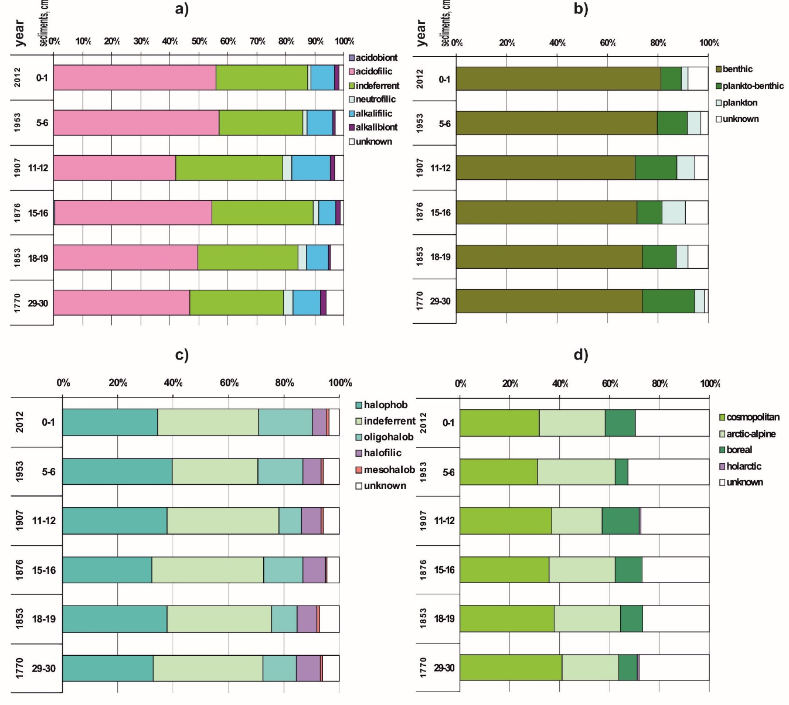
Fig.5. Ecological characteristics of the diatom complexes in the Harrijarvi Lake: a) – pH-tolerance groups; b) – habitat groups; c) – salinity groups; d) – biogeographic groups.

The changes of the ecological conditions of Harrijarvi Lake can be assessed proceeding from the dynamics of the diatom groups in relation to environmental factors (Fig.5.). Reduction of the portion of acidobionts was noted in the ratio of diatoms tolerance groups and pH, along with increase of alcalifilic at the turn of the XX century, as a result of warming and increase of water amount in the lake. Water mineralization practically has not changed throughout the whole period under study: halophobs and oligohalobs-indifferents have a significant portion in diatom complexes (up to 40 %), which is characteristic of subarctic water bodies.
Bottom, benthic forms of diatoms dominated in the water body throughout its whole historical period under study. It is the characteristic feature of small subarctic water bodies where small depths and high transparency contribute to the development of rich bottom communities. Some reduction of the portion of bottom forms at the turn of the century is, evidently, the consequence of increased water level and water amount in the lake.
Change of environmental conditions early in the XX century is confirmed by the dynamics of the ratio of biogeographic groups of diatoms. Some reduction of the arctic-alpine portion along with increase of boreal forms occurred. The arctic-alpine portion has grown again in the modern diatom complexes.
Thus, ecological conditions of Harrijarvi Lake over 240 years underwent a number of changes in response to the dynamics of the climatic system and environmental conditions. The most significant changes occurred at the turn of the XX century primarily due to climate warming. Later, industrial factors began to impact the development of the water body, which had an effect on hydrochemical characteristics of the lake – reduction of pH occurred as a result of fallout of acidifying compounds. Present day diatom complexes from the top layers of sediments are the evidence of the reduction of aerotechnogenic pollution.
Throughout the whole studied period the water body corresponded to a typical subarctic lake, with low mineralization and oligotrophic trophic status, no fundamental changes in the structure of diatom complexes were found. Also, no obvious consequences of the current climate warming were detected; warming of early XX century was more significant for the ecosystem of Harrijarvi Lake.
Rabbvatnet Lake. Diatom complexes were analyzed in the top layer of sediments (interval 0-1 cm) – reflecting the present-day condition of the lake ecosystem, as well as in different parts of the column (intervals 1-1.5, 4-4.5, 6-6.5, 10-11, 20-21, 30-31, 42- 43, and 43-44 cm), formed in different historical stages of the lake development. The total age of the sediments under study is 680 years.
Typical representatives in the diatom complexes were: Aulacoseira alpigena (Grun.) Krammer; Pseudostaurosira brevistriata (Grun.) D.M. Williams & Round; Cyclotella ocellata Pant.; Cyclotella bodanica Eulenstein. Staurosira construens Ehrb is also present in the top layers of the sediments.
The following species play the role of the subdominants in the middle part of the column: Tabellaria flocculosa (Roth) Kütz.; Denticula tenuis var. tenuis Kütz.Cyclotella rossii Håk.; Cyclotella bodanica var. lemanica (O. Müll. ex Schröter) Bachm.; Cyclotella schumannii (Grunow) Håk.
Also numerous in the most ancient layers were: Fragilariforma virescens (Ralfs) D.M.Williams & Round and Cyclotella michiganiana Skvortzov 1937.
Thus, the mass species throughout the whole studied period were the representatives of plankton, characteristic of the water bodies of the European North with pH≥ 7.0.
Diatom complexes of the studied column of bottom sediments are characterized by significant changes both in the quantitative characteristics and in the dynamics of the ecological structure. The total abundance of diatoms (N) is characterized by the trend of gradual growth from the lower intervals of sediments towards the upper intervals, and it grows almost by 10 times (Fig. 6). At the same time, two maximums can be seen: 4 – 6.5 cm in the layer of sediments aged approximately 70-100 years old, and in the very top, present-day layers – 0 – 0.5 cm. Thus, the primary productivity of the water body has gradually grown. The species diversity of diatoms has also changed: starting from the ancient layers of sediments (43-41 cm), a gradual increase of the species diversity index (H’) occurred up to the layers of 10-11 cm, corresponding to the 1930’s. The maximum species diversity index was observed here. Probably, this process is the consequence of ending of the Little Ice Age and appearance of new ecological niches for development of diatoms.
Further warming early in the XX century led to growth of diatoms’ abundance along with reduction of species diversity (Fig. 6).
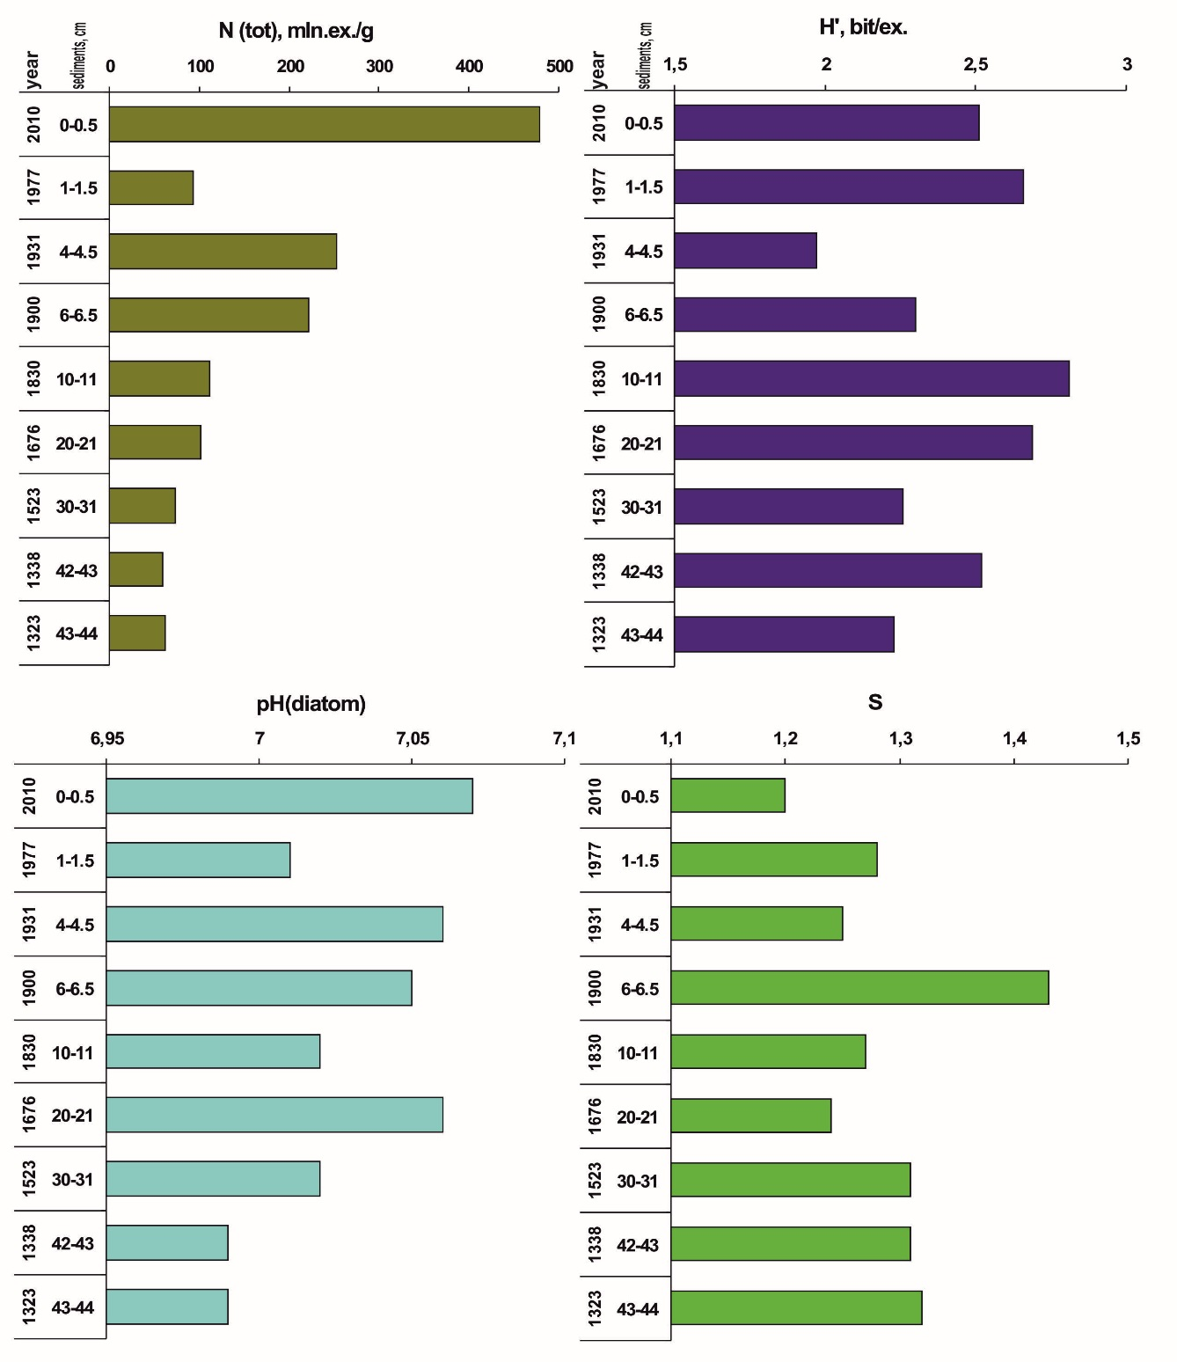
Fig.6. Diatom complexes of the Rabbvatnet Lake: total abundance (N(tot), mln.ex./g); specific variety (H’, bit/ex.); diatom-infer reconstructed pH (pH(diatom)); saprobe index (S).

The value of the Shannon-Weaver index (H’) grows again towards present-day bottom sediments in response to changing environmental conditions, probably caused by two factors – climatic changes towards warming along with industrial impact (aerotechnogenic pollution). Deposition of acidifying compounds changed hydrochemical conditions towards some reduction of pH, which allowed for development of the diatoms, preferring more acidic media.
Reconstruction of pH from diatom complexes showed that throughout the whole period under study the lake water was characterized by near-neutral values; fluctuations were insignificant. In the XIV century the water body was characterized by more acidic conditions with pH< 7.0, which was caused by the influence of the Little Ice Age. Closer to the XVI century pH somewhat grew and since then it has never dropped below 7.0. The maximum values of active reaction were characteristic of the early XX century and of the present-day stage of development of the water body. These particular periods are described as the warmest. Reduction of pH in the middle of the XX century is the direct consequence of deposition of acidifying compounds, associated with operation of the Pechenganikel integrated plant. At the same time this reduction does not exceed natural fluctuations of pH (Fig. 6).
Evidently, the most significant transformations in the ecosystem of the water body occurred at the turn of the XX century. In this period many complex ecological indicators, calculated according to diatom complexes, are characterized by extreme values. Presumably, in this period some transformation of the trophic structure of the communities of hydrobionts occurred, which manifested itself in the maximum saprobity index in the layers, corresponding to the year 1900 (Fig. 6). The same was also observed in Harrijarvi Lake (Fig. 4).

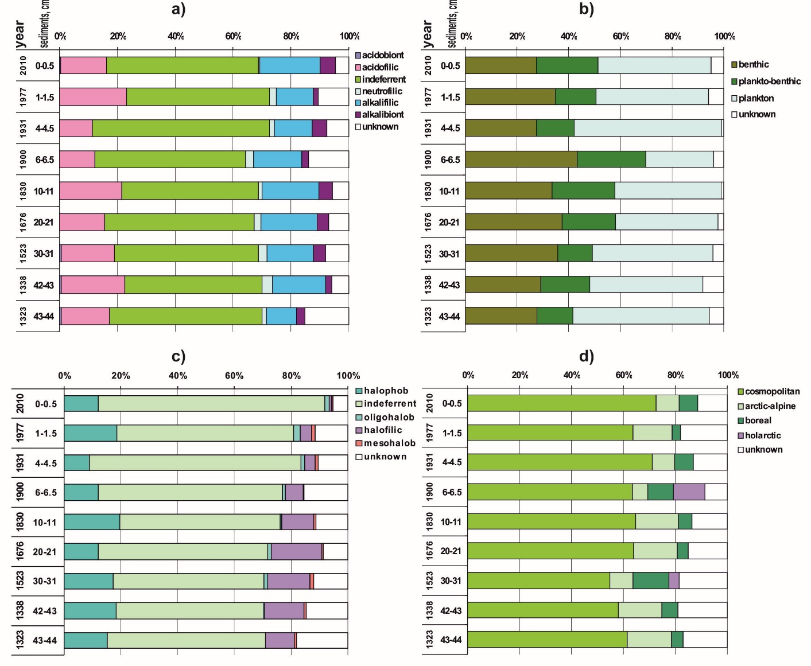
Fig.7. Ecological characteristics of the diatom complexes in the Rabbvatnet Lake: a) – pH-tolerance groups; b) – habitat groups; c) – salinity groups; d) – biogeographic groups.

Changes were also noted in the ecological structure of the diatom complexes of Rabbvatnet Lake (Fig. 7). Judging by the ratio of diatoms tolerance groups according to pH reaction one may see that indifferent forms dominated throughout the whole historical period under study, acidobionts practically never were found. The ratio of acidofilic and alcalifilic groups illustrates some changes of acidic-alkaline conditions. No fundamental changes were detected. Water salinity also hasn’t significantly changed throughout the whole studied period: a trend of increasing portion of indifferent group of diatoms was noted along with reduction of the halofilous portion. Presumably, the ratio of these groups reflects primarily the intensiveness of erosion processes in the lake’s catchment area. The salinity was evidently the highest in the Little Ice Age, when catchment was minimal. Throughout the whole period under study typical halophob diatoms characteristic of arctic and subarctic freshwater ecosystems were developing in the lake.
One can judge about the changes of water levels and water content by the dynamics of ratio of the groups in relation to their habitat. Gradual reduction of the portion of plankton forms in the period from the XIV century through late XVIII century, evidently illustrates reduction of the water amount in the lake on the background of climatic cooling in the Little Ice Age. At the same time, the portion of benthic and plankton-benthic algae grows – the sign of development of littoral and bottom communities in the lake that has grown shallow. Climate warming early in the XX century again caused increase of water level and development of planktonic diatoms. Evidently, in the 1930’s the lake had more water than today.
Proceeding from the ratio of diatoms group in relation to biogeography, one can see that throughout the whole studied period of the development of the water body ecosystem, the arctic-alpine forms formed a significant portion (up to 18 %), while the boreal portion was insignificant. Thus, typically northern subarctic diatom flora dominated in the lake. Impact of the climatic factors on the ratio of the biogeographical groups of diatom complexes evidently manifested itself poorly against the background of other external impacts.
Thus, ecological conditions of Rabbvatnet Lake over the last 680 years have undergone a number of changes in response to the dynamics of the climatic system and environmental conditions. Throughout the whole studied period the water body corresponded to a typical subarctic lake, with low salinity, near-neutral values of pH and oligotrophic trophic status. Significant transformations in the ecosystem were caused by the Little Ice Age, when the water body grew shallow and the reduction of the biological productivity of algae occurred. At the turn of the XX century the climate changed, which led to growth of water level and to growth of diatom numbers. The impact of aerotechnogenic pollution, associated with operation of the Pechenganikel integrated plant, manifested itself in small reduction of pH in the second half of the XX century. The present-day diatom complexes from the upper layers of sediments confirm the reduction of aerotechnogenic pollution as well as the more favorable climatic conditions for development of diatoms, which manifests itself in a dramatic increase of quantitative parameters.
Conclusion
Diatom complexes of all the water bodies under study testify of the changes occurring in their ecosystems over the studied historical periods. The consequences of impact from two main groups of factors for all lakes have been detected: natural processes associated with the dynamics of the climatic system, and industrial processes, associated with operation of the Pechenganikel integrated plant. No fundamental changes in the ecosystems of the water bodies have been detected; they all correspond to typical subarctic oligotrophic lakes with low salinity of water.
The most important climatic events in the development of lakes were the Little Ice Age (XIV–XIX centuries), when low temperatures contributed to acidification, reduction of water amount and to reduction of the intensiveness of production processes, as well as warming in the XX century, which maximums fell on the period 1900 through 1930 and on the two latest decades. In between these events, along with cooling, the condition of the ecosystems of the lakes was impacted by industrial load, primarily, by acidification caused by deposition of acidifying compounds as a result of operation of the Pechenganikel integrated plant. At present the consequences of production decrease are showing. It is impossible to draw a decisive conclusion regarding the dramatic climate changes in the latest decades. Warming early in the XX century turned out to be more significant for the studied water bodies. At the same time, the remaining level of industrial load, evidently, impedes the analysis of the consequences of climatic changes.

Reference literature

- Krammer, K. and Lange-Bertalot, H. 1986. Bacillariophyceae. 1. Teil: Naviculaceae. inEttl, H., Gerloff, J., Heynig, H. and Mollenhauer, D. (eds) Süsswasser flora von Mitteleuropa, Band 2/1. GustavFischerVerlag: Stuttgart, NewYork. 876 pp.
- Krammer, K. and Lange-Bertalot, H. 1988. Bacillariophyceae. 2. Teil: Bacillariaceae, Epithemiaceae, Surirellaceae. inEttl, H., Gerloff, J., Heynig, H. and Mollenhauer, D. (eds) Süsswasserflora von Mitteleuropa, Band 2/2. VEB GustavFischerVerlag: Jena. 596 pp.
- Krammer, K. and Lange-Bertalot, H. 1991a. Bacillariophyceae. 3. Teil: Centrales, Fragilariaceae, Eunotiaceae. inEttl, H., Gerloff, J., Heynig, H. and Mollenhauer, D. (eds) Süsswasserflora von Mitteleuropa, Band 2/3. GustavFischerVerlag: Stuttgart, Jena. 576 pp.
- Krammer, K. and Lange-Bertalot, H. 1991b. Bacillariophyceae. 4. Teil: Achnanthaceae, KritischeErgänzungenzuNavicula (Lineolatae) und Gomphonema, GesamtliteraturverzeichnisTeil 1-4. inEttl, H., Gärtner, G., Gerloff, J., Heynig, H. and Mollenhauer, D. (eds) Süsswasserflora von Mitteleuropa, Band 2/4. GustavFischerVerlag: Stuttgart, Jena. 437 pp.
- Krammer K. The genus Pinnularia. In: H. Lange-Bertalot (ed.), Diatoms of Europe. 1: A.R.G. GantnerVerlag K.G., Vaduz, 2000, 703 p.
- KrammerK.Cymbopleura, Delicata, Navicymbula, Gomphocymbellopsis, Afrocymbella. In: H. Lange-Bertalot (ed.), Diatoms of Europe, 4:A.R.G. GantnerVerlag K.G., Ruggell, 2003, 530 p.
- KrammerK. Cymbella. In: H. Lange-Bertalot (ed.), Diatoms of Europe.3: A.R.G. GantnerVerlag K.G., Ruggell, 2002, 584 p.
- Korhola A., Sorvari S., Rautio M., Appleby P.G., Dearing J.A., Hu Y., Rose N., Lami A., Cameron N.G. A multi-proxy analysis of climate impacts on therecent development of subarctic Lake Saanajärvi in Finnish Lapland. Journal of Paleolimnology 28: 2002. 59–77 pp.

